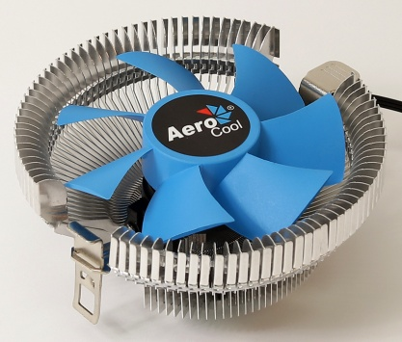
Product Overview:
PWM air cooling solution equipped with high efficiency fins and compact profile. Compatible with most current AMD motherboard designs. Only for AMD chipset configurations.
Specifications

Model |  | Verkho A
Base Material |  | Aluminum
Dimension |  | 112 x 112 x 55mm
TDP(Thermal Design Power) |  | 100
Fan | Speed | 1000-2300 rpm
 | Connector | PWM 4-Pin
 | Dimension | 90 x 90 x 25mm
 | Bearing Type | Hydraulic Bearing
 | Started Voltage | 6V
 | Rated Voltage | 12V
 | Rated Current | 0.24 A
 | Power Consumption | 2.88 Watts (One Fan)
 | Air Pressure | 0.59-1.34 mm-H2O
 | Air Flow | 26.51-61.32 CFM
 | Noise | 10.85-28.9dBA
 | MTBF  (Mean Time Before Failure) | 60000 hrs.
Socket |  | AM4/AM3+/AM3/AM2+/AM2/ FM2/FM1

Warranty

1 year

Features

- TDP (Thermal Design Power) up to 100W.
- Upgraded high efficiency fins for optimal thermal performance.
- Compact profile capable of mounting single 90mm fan configurations; works with most current AMD motherboard designs. Only for AMD chipset configurations.

Package Information

Product Name | Product Number | EAN CODE | UPC CODE
Verkho A | ACTC-NA20010.01 | 4710700950807
Carton Size ( L x W x H ) | 625 x 375 x 280 mm | Carton Weight | N.W 14.8 kg / G.W 16.2 kg
Retail Box Size ( L x W x H ) | 120 x 120 x 65 mm | Retail Box Weight | N.W 199 g / G.W 248 g
Carton Qty | 60 pcs | Pallet Qty | 1680(GP)/2160(HQ)

